Staff Maintenance Menu

Screen Shot:

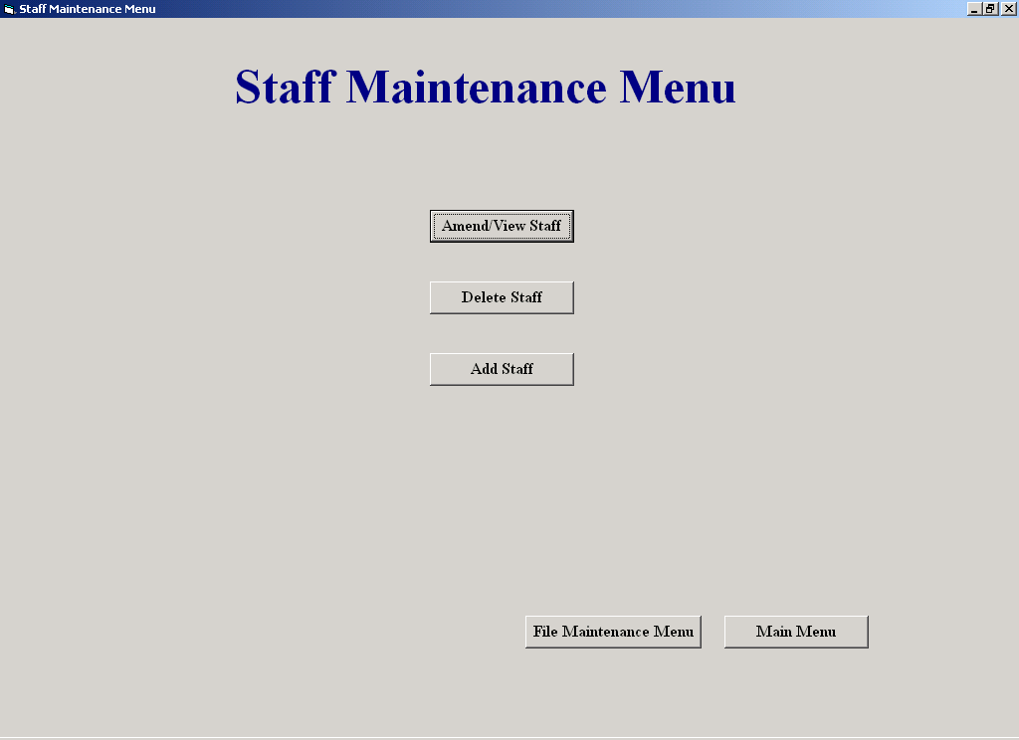

Code:

Allows the user access to staff processing screens such as, Delete a Staff Member and
Amend/View Staff.

Author: Sean O'Brien
Date: 20-03-2002

Variables Used -
None

Objects Used -
None

Option Explicit

Private Sub cmdBack_Click()
(Unloads this screen and shows the File Maintenance Menu)
frmFileMaintenanceMenu.Show
Unload Me
End Sub
Private Sub cmdDelStaff_Click()
(Unloads this screen and shows the Delete Staff screen)
frmDelStaff.Show
Unload Me
End Sub

Private Sub cmdMainMenu_Click()
(Unloads this screen and shows the Main Menu)
frmMainMenu.Show
Unload Me
End Sub

Private Sub cmdViewStaff_Click()
(Unloads this screen and shows the Amend/View Staff screen)
frmAmendViewStaff.Show
Unload Me
End Sub

Clock In Staff

Screen Shot:

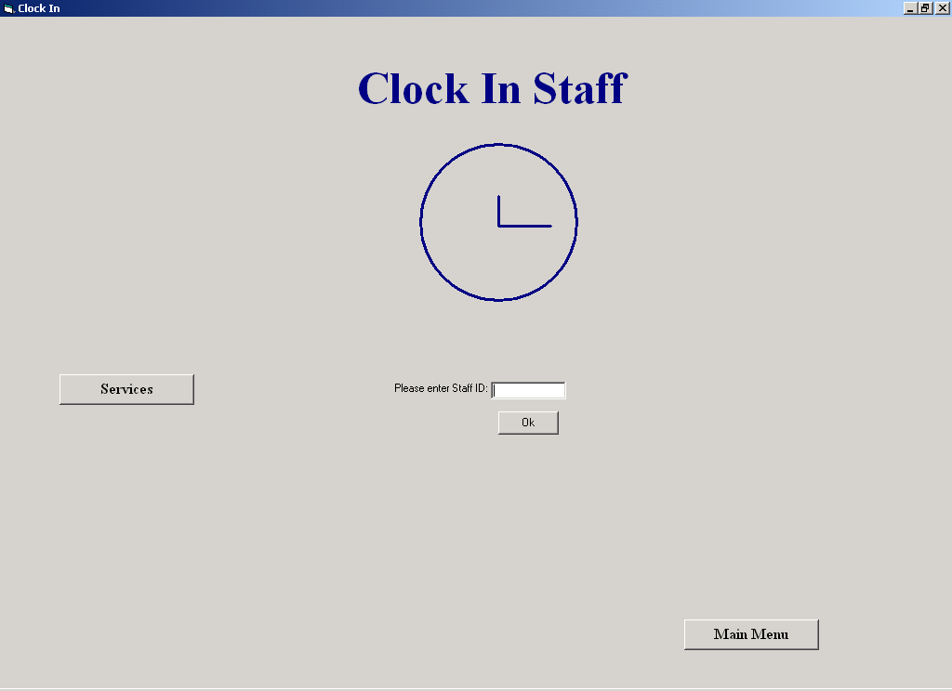

Code:

This screen allows the user to clock in or out, it also allows access to other services such as
Calculating Hours Worked and Clock In Times for the day.
The user enters his or her employee ID and clicks "OK"

Author: Sean O'Brien
Date: 20-03-2002

Variables Used -
TheLastId : Integer (Holds the last primary Clock-In ID in the Clock-In table)
ID : Integer (holds the employee id)
strSQL : String (Holds SQL statements)
Counter : Integer (Control variable in a loop)
CountUp : Integer (indicates whether the value entered was numeric)

Objects Used -
datTime : Data Control (Used to access the Employee and Clock-In tables in the database)
datCount : Data Control (Used to access the Clock-In table in the database)

Option Explicit

Private Sub cmdMainMenu_Click()
(Unloads this screen and shows the Main Menu)
frmMainMenu.Show
Unload Me
End Sub

Private Sub cmdOk_Click()
(Finds out whether the employee wants to clock in or out and then clocks the employee in or out)
Dim TheLastId, ID As Integer
Dim strSQL As String
ID = Val(txtEmpId.Text)
strSQL = "Select * From Employee " & _
"Where Deletion = False " & _
"And Employee_ID = " & ID & ""
datTime.RecordSource = strSQL
datTime.Refresh
If (datTime.Recordset.RecordCount > 0) Then
datTime.RecordSource = "Clock-In"
datTime.Refresh
If datCount.Recordset.RecordCount = 0 Then
TheLastId = -1
Else
datCount.Recordset.MoveLast
TheLastId = datCount.Recordset("ClockIn_ID")
End If
datCount.RecordSource = "SELECT Count(*) AS TheCount From [Clock-In] Where Employee_ID = " & ID & ""
datCount.Refresh
If datCount.Recordset.Fields("TheCount") > 0 Then
datTime.RecordSource = "SELECT * From [Clock-In] Where Employee_ID = " & ID & ""
datTime.Refresh
datTime.Recordset.FindFirst ("[Time Out] Is Null")
If datTime.Recordset.NoMatch Then
PutInTable (TheLastId)
Else
datTime.Recordset.Edit
datTime.Recordset("Time Out") = FormatDateTime(Now, vbShortTime)
datTime.Recordset.Update
datCount.RecordSource = "Clock-In"
datCount.Refresh
End If
Else
PutInTable (TheLastId)
End If
Else
MsgBox "This is not a valid id, please try again", vbExclamation
End If
txtEmpId.SetFocus
End Sub

Private Sub cmdServices_Click()
(Hides this screen and shows the "Services" screen)
frmClockIn.Hide
frmServices.Show
End Sub

Private Sub Form_Activate()
(Puts the focus in the textbox "txtEmpId")
txtEmpId.SetFocus
End Sub

Private Sub Form_Load()
(Sets the data control, "datCount" to access the details of the Clock-In table in the database)
(Sets the data control, "datTime" to access the details of the Clock-In table in the database)
datCount.DatabaseName = strThePath
datCount.RecordSource = "Clock-In"
datCount.Refresh
datTime.DatabaseName = strThePath
datTime.RecordSource = "Clock-In"
datTime.Refresh
End Sub

Public Sub PutInTable(LastId As Integer)
(Enter the details into the Database)
datTime.Recordset.AddNew
datTime.Recordset("Employee_ID") = txtEmpId.Text
datTime.Recordset("Time In") = FormatDateTime(Now, vbShortTime)
datTime.Recordset("Time Out") = Null
datTime.Recordset("Date") = FormatDateTime(Now, vbShortDate)
datTime.Recordset("ClockIn_ID") = LastId + 1
datTime.Recordset.Update
txtEmpId.SetFocus
End Sub

Private Sub txtEmpId_GotFocus()
(makes the screen ready for another clock in)
txtEmpId.Text = ""
cmdOk.Enabled = True
datCount.RecordSource = "Clock-In"
datCount.Refresh
End Sub
Private Sub txtEmpId_Validate(Cancel As Boolean)
(ensures the user enters a valid ID)
Dim counter, CountUp As Integer
If Len(txtEmpId.Text) = 0 Then
Cancel = True
If MsgBox("Please enter employee number", vbOKOnly, "Warning") = vbOK Then
txtEmpId.SetFocus
End If
Else
For counter = 1 To Len(txtEmpId.Text)
If IsNumeric(Mid(txtEmpId, counter, 1)) Then
CountUp = CountUp + 1
End If
Next
If Not (CountUp = Len(txtEmpId.Text)) Then
Cancel = True
Call MsgBox("Supplier ID must be numeric", vbOKOnly, "Warning")
txtEmpId.Text = ""
Else
Cancel = False
End If
End If
End Sub

Services

Screen Shot:

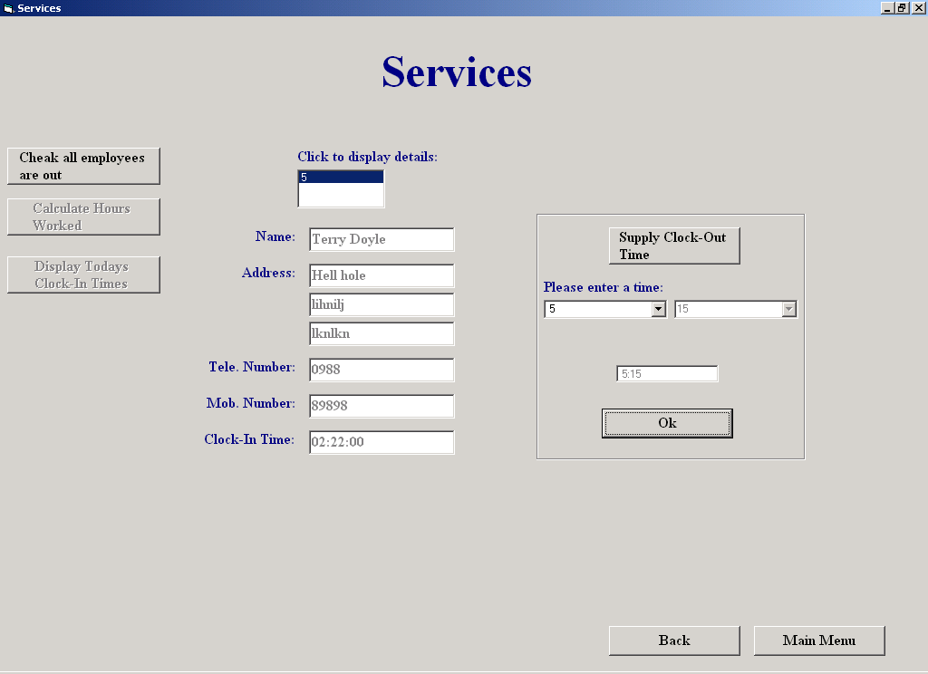

Code:

This screen allows the user to check that all employees are clocked out. Once all employees are clocked out,
the user can then calculate the hours worked for the week for each employee. The user can also get a
listing of clock in times for the day, the system automatically marks those employees
who arrived late and those who left early.

The user must first find out if all employees have clocked out. A listing of those
who haven't clocked out, is displayed. The user clicks on their ID number to view
their details and then has the option of supplying a clock out time for them. To do
this, the user must first choose the hours and then the minutes from two Comboboxes
and then click "OK".
Once all employees are clocked out, hours worked for the week can be calculated by
clicking "Calculate Hours Worked", and also see a list of clock in times for the day
can be displayed by clicking "Display Today’s Clock-In Times"

Author: Sean O'Brien
Date: 20-03-2002

Variables Used -
InTime : String (Holds the last time the employee clocked in)
EnteredTime : String (Holds the clock out time for the employee)
Counter : Integer (Control Variable in a loop)
TheId : Integer (holds the employee's id)
TheDiff : Integer (holds the hours worked for each employee)
Diff : Currency(Holds the total amount of minutes worked for the week for each employee)
strSQL : String (Holds SQL statements)
TheFirstHour : String (Holds the Clock In time)
TheSecHour : String (Holds the Clock Out time)
AllTheId : String (Holds the Id's of all the employees that clocked in today)
Status : String (Indicates whether an employee arrived late)
Left : String (Indicates whether an employee left early)
Temp : String (Stores the variable "Left" temporarily)
TheArray : Variant (An array which holds the Id's from all the employees that clocked in today)
TheDate : Date (Holds today’s date)
ClockID : Integer (Holds the primary Id,"ClockIn_ID" in the Clock-In table)
index : Integer (control variable in a loop)

Objects Used -
datTime : Data Control (Used to access the Clock-In table in the database)
datCount : Data Control (Used to access the Employee and Clock-In tables in the database)

Dim EnteredTime, InTime As String
Option Explicit

Private Sub cmdClockIn_Click()
(Unloads this screen and shows the clock-in screen)
Unload Me
frmClockIn.Show
End Sub

Private Sub cmdMainMenu_Click()
(Unloads this screen and shows the Main Menu)
frmMainMenu.Show
Unload Me
End Sub

Private Sub cmdSupplyTime_Click()
(initializes the "cmbHours" combobox)
Dim counter As Integer
counter = InTime
cmbHours.Enabled = True
While counter <= 23
cmbHours.AddItem (Str(counter))
counter = counter + 1
Wend
cmbHours.AddItem ("00")
lblTime.Enabled = True
End Sub

Private Sub Form_Load()
(Sets both data controls to access the Clock-In table in the database)
datCount.DatabaseName = strThePath
datCount.RecordSource = "Clock-In"
datCount.Refresh
datTime.DatabaseName = strThePath
datTime.RecordSource = "Clock-In"
datTime.Refresh
End Sub

Private Sub lstStaff_Click()
(Finds an employee with a particular ID and then calls a procedure which displays his or her details)
Dim TheId As Integer
datTime.RecordSource = "Clock-In"
datTime.Refresh
TheId = lstStaff.ItemData(lstStaff.ListIndex)
datTime.Recordset.FindLast "Employee_ID = " & TheId & ""
txtClockInTime.Text = datTime.Recordset("Time In")
InTime = Val(datTime.Recordset("Time In"))
TheId = lstStaff.ItemData(lstStaff.ListIndex)
datTime.RecordSource = "Employee"
datTime.Refresh
datTime.Recordset.FindFirst "Employee_ID = " & TheId & ""
Call DisplayDetails
End Sub

Private Sub cmdOk_Click()
(Enters the clock out time for the employee, resets the screen)
txtTheTime.Text = EnteredTime
Dim TheId As Integer
If IsDate(EnteredTime) Then
TheId = lstStaff.ItemData(lstStaff.ListIndex)
datCount.Recordset.FindFirst "Employee_ID = " & TheId & ""
datCount.Recordset.Edit
datCount.Recordset("Time Out") = EnteredTime
datCount.Recordset.Update
cmdOk.Enabled = False
cmdSupplyTime.Enabled = False
cmbHours.Text = "Please choose Hour"
cmbHours.Enabled = False
cmbMinutes.Text = "Please choose minute"
cmbMinutes.Enabled = False
lblTime.Enabled = False
EnteredTime = 0
txtTheTime.Text = ""
lstStaff.RemoveItem (lstStaff.ListIndex)
txtEmpName.Text = ""
txtAddress1.Text = ""
txtAddress2.Text = ""
txtAddress3.Text = ""
txtTelNum.Text = ""
txtMobNum.Text = ""
txtClockInTime.Text = ""
If lstStaff.ListCount = 0 Then
lstStaff.Visible = False
lblDisplay.Visible = False
cmdDisplayTimes.Enabled = True
cmdGetDiff.Enabled = True
End If
Reset1
Else
MsgBox "Please enter a valid time in the format hh:mm", vbExclamation
cmbHours.SetFocus
End If
End Sub

Private Sub cmdGetDiff_Click()
(Calculates the hours worked for each employee and displays it on the screen)
Dim TheId, TheDiff As Integer
Dim Diff As Currency
Dim strSQL, TheFirstHour, TheSecHour As String
datCount.RecordSource = "Employee"
datCount.Refresh
datTime.RecordSource = "Clock-In"
datTime.Refresh
lblHours.Visible = True
lstDisplay.Visible = True
lstDisplay.Clear
lstDisplay.AddItem ("Employee ID" & Chr(9) & "Employee Name" & Chr(9) & "Hours Worked")
While Not datCount.Recordset.EOF
TheId = datCount.Recordset("Employee_ID")
strSQL = "Select * From [Clock-In] where Employee_ID = " & TheId & ""
datTime.RecordSource = strSQL
datTime.Refresh
Diff = 0
While Not datTime.Recordset.EOF
TheFirstHour = datTime.Recordset("Time In")
TheSecHour = datTime.Recordset("Time Out")
Diff = Diff + DateDiff("n", TheFirstHour, TheSecHour) 'gets the total amount of minutes worked for the week
datTime.Recordset.MoveNext
Wend
TheDiff = Round(Diff / 60) 'gets the hours worked for the week
datCount.Recordset.Edit
datCount.Recordset("HoursWorked") = TheDiff
datCount.Recordset.Update
lstDisplay.AddItem (datCount.Recordset("Employee_ID") & Chr(9) & Chr(9) & datCount.Recordset("Employee Name") & Chr(9) & Chr(9) & datCount.Recordset("HoursWorked"))
datCount.Recordset.MoveNext
Wend
lstDisplay.Visible = True
End Sub

Private Sub cmdDisplayTimes_Click()
(Displays the clock in times for today)
Dim strSQL, AllTheId, Status, Left, Temp As String
Dim TheArray
Dim TheDate As Date
Dim TheId, ClockID, index As Integer
AllTheId = ""
cmdDisplayTimes.Tag = "0"
TheDate = FormatDateTime(Now, vbShortDate)
strSQL = "SELECT [Clock-In].[ClockIn_ID], [Clock-In].[Employee_ID], [Employee].[Employee Name], [Clock-In].[Time In]," & _
"[Clock-In].[Time Out], [Clock-In].[Date]" & _
"FROM [Clock-In] INNER JOIN Employee ON [Clock-In].[Employee_ID]=[Employee].[Employee_ID]" & _
"Where ((([Clock-In].[Date]) = #" & TheDate & "#" & "))" & _
"ORDER BY [Clock-In].[ClockIn_ID],[Clock-In].[Employee_ID];" 'gets everyone that clocked in today
datTime.RecordSource = strSQL
datTime.Refresh
While Not datTime.Recordset.EOF
If InStr(AllTheId, Str(datTime.Recordset("Employee_ID"))) = False Then
AllTheId = AllTheId + Str(datTime.Recordset("Employee_ID")) + "," 'gets the ID of each employee that clocked in today
cmdDisplayTimes.Tag = Str(Val(cmdDisplayTimes.Tag) + 1) 'stores the number of employees that clocked in today
End If
datTime.Recordset.MoveNext
Wend
datTime.Refresh
TheArray = Split(AllTheId, ",")
index = 0
datCount.RecordSource = strSQL
datCount.Refresh
If datCount.Recordset.RecordCount = 0 Then
Call MsgBox("No employees have clocked in today", vbOKOnly, "No Clock-Ins")
Else
lblTimes.Visible = True
lstDisplayTimes.Visible = True
lstDisplayTimes.Clear
lstDisplayTimes.AddItem ("Employee ID" & Chr(9) & "Employee Name" & Chr(9) & Chr(9) & "Clock In" & Chr(9) & Chr(9) & "Time Out" & Chr(9) & Chr(9) & "Arrived" & Chr(9) & Chr(9) & "Left")
While index < Val(cmdDisplayTimes.Tag)
TheId = TheArray(index)
datCount.Recordset.FindFirst "Employee_ID = " & TheId & ""
datTime.RecordSource = "Select Count(*) as Counter From [Clock-In]" & _
" Where [Employee_ID] = " & TheId & "" & _
" And Date = #" & TheDate & "#"
datTime.Refresh
ClockID = datCount.Recordset("ClockIn_ID")
If (Val(datCount.Recordset("Time In")) >= Val("10:00")) Then
Status = "Late"
Else
Status = "On Time"
End If
Left = ""
datCount.Recordset.FindLast "Employee_ID = " & TheId & ""
If (Val(datCount.Recordset("Time Out")) <= Val("15:30")) Then
Left = "Early"
Else
Left = "On Time"
End If
If datTime.Recordset("Counter") = 1 Then
lstDisplayTimes.AddItem (datCount.Recordset("Employee_ID") & Chr(9) & Chr(9) & datCount.Recordset("Employee Name") & Chr(9) & Chr(9) & datCount.Recordset("Time In") & Chr(9) & Chr(9) & datCount.Recordset("Time Out") & Chr(9) & Chr(9) & Status & Chr(9) & Chr(9) & Left)
Else
datCount.Recordset.FindFirst "Employee_ID = " & TheId & ""
Temp = Left
Left = ""
lstDisplayTimes.AddItem (datCount.Recordset("Employee_ID") & Chr(9) & Chr(9) & datCount.Recordset("Employee Name") & Chr(9) & Chr(9) & datCount.Recordset("Time In") & Chr(9) & Chr(9) & datCount.Recordset("Time Out") & Chr(9) & Chr(9) & Status & Chr(9) & Chr(9) & Left)
datCount.Recordset.FindLast "Employee_ID = " & TheId & ""
Left = Temp
Status = ""
lstDisplayTimes.AddItem (datCount.Recordset("Employee_ID") & Chr(9) & Chr(9) & datCount.Recordset("Employee Name") & Chr(9) & Chr(9) & datCount.Recordset("Time In") & Chr(9) & Chr(9) & datCount.Recordset("Time Out") & Chr(9) & Chr(9) & Status & Chr(9) & Chr(9) & Left)
End If
index = index + 1
datCount.Refresh
Wend
End If
End Sub

Private Sub cmdCheck_Click()
(Checks to see has all employees clocked out)
lstStaff.Clear
datCount.RecordSource = "Select * From [Clock-In] Where [Time Out] Is Null"
datCount.Refresh
If datCount.Recordset.RecordCount = 0 Then
txtEmpName.Text = ""
txtAddress1.Text = ""
txtAddress2.Text = ""
txtAddress3.Text = ""
txtTelNum.Text = ""
txtMobNum.Text = ""
Call MsgBox("There are no employees clocked in", vbOKOnly, "Warning")
cmdGetDiff.Enabled = True
cmdDisplayTimes.Enabled = True
Else
lblDisplay.Visible = True
lstStaff.Visible = True
datCount.Recordset.MoveFirst
While Not datCount.Recordset.EOF
lstStaff.AddItem (datCount.Recordset("Employee_ID"))
lstStaff.ItemData(lstStaff.NewIndex) = datCount.Recordset("Employee_ID")
datCount.Recordset.MoveNext
Wend
End If
End Sub

Public Sub DisplayDetails()
(Displays an employee's details)
txtEmpName.Text = datTime.Recordset("Employee Name")
txtAddress1.Text = datTime.Recordset("Address 1")
txtAddress2.Text = datTime.Recordset("Address 2")
txtAddress3.Text = datTime.Recordset("Address 3")
txtTelNum.Text = datTime.Recordset("Phone No")
txtMobNum.Text = datTime.Recordset("Mobile No")
txtEmpName.Visible = True
txtAddress1.Visible = True
txtAddress2.Visible = True
txtAddress3.Visible = True
txtTelNum.Visible = True
txtMobNum.Visible = True
txtClockInTime.Visible = True
cmdSupplyTime.Enabled = True
lblName.Visible = True
lblAdd.Visible = True
lblTelNum.Visible = True
lblMobNum.Visible = True
lblClock.Visible = True
frSupply.Visible = True
End Sub

Private Sub cmbHours_Click()
(Gets the Hours field of the clock out time)
txtTheTime.Text = ""
EnteredTime = cmbHours.Text
If cmbHours.Text = "00" Then
txtTheTime.Text = "00:00"
cmdOk.Enabled = True
EnteredTime = "00:00"
Else
cmbMinutes.Enabled = True
End If
End Sub

Private Sub cmbMinutes_Click()
(Gets the Minutes field of the clock out time)
EnteredTime = EnteredTime + ":" + cmbMinutes.Text
txtTheTime.Text = EnteredTime
cmdOk.Enabled = True
cmbMinutes.Enabled = False
End Sub

Private Sub Reset1()
(Resets the screen)
txtEmpName.Visible = False
txtAddress1.Visible = False
txtAddress2.Visible = False
txtAddress3.Visible = False
txtTelNum.Visible = False
txtMobNum.Visible = False
txtClockInTime.Visible = False
lblName.Visible = False
lblAdd.Visible = False
lblTelNum.Visible = False
lblMobNum.Visible = False
lblClock.Visible = False
frSupply.Visible = False
End Sub

Add Supplier

Screen Shot:

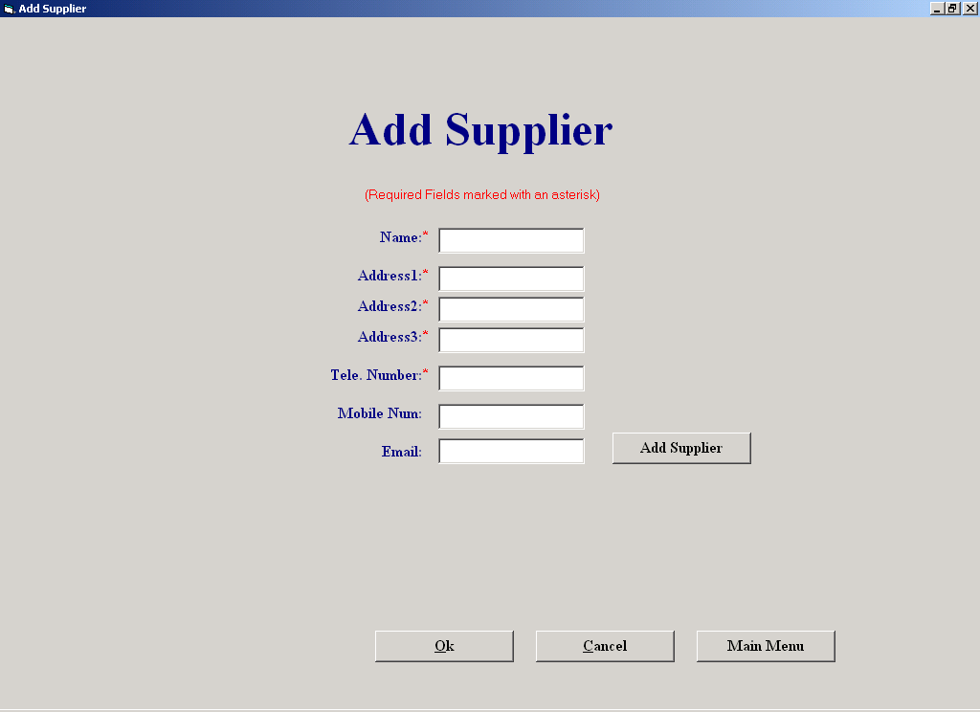

Code:

The purpose of this screen is to allow the user to enter the details of a new supplier.
The user enters the details of the supplier in the relevant textboxes and then clicks
"Add Supplier".
If the user clicks "Cancel", any suppliers that were entered since this screen was last
invoked, are completely deleted from the system.

Author: Sean O'Brien
Date: 20-03-2002

Variables Used -
MyString : String (Holds the telephone number of a supplier)
TheLastId : String (Holds the primary ID of the last record in the current Supplier table)
Counter : Integer (Control variable of a loop)
Answer : Boolean (indicates whether the user wishes to save the details he has just entered)
CountUp : Integer (indicates how many characters in a string are numeric)
Objects Used -
datAddSupplier : Data Control (Used to access the supplier table in the database)

Option Explicit

Private Sub cmdAddSupplier_Click()
(This procedure adds a supplier to the database if the supplier doesn't already exists)
If (Len(txtSuppName.Text) > 0) And (Len(txtAdd1.Text) > 0) And (Len(txtAdd2.Text) > 0) And (Len(txtAdd3.Text) > 0) And (Len(txtTelNum.Text) > 0) Then
Dim MyString, TheLastId As String
datAddSupplier.RecordSource = "Select * From Supplier Order By Supplier_ID"
datAddSupplier.Refresh
datAddSupplier.Recordset.MoveLast
TheLastId = datAddSupplier.Recordset("Supplier_ID")
datAddSupplier.RecordSource = "Select * from Supplier where [Deletion] = False Order By Supplier_ID"
datAddSupplier.Refresh
MyString = txtTelNum.Text
datAddSupplier.Recordset.FindFirst "[Phone No] = '" & MyString & "'"
If datAddSupplier.Recordset.NoMatch Then
datAddSupplier.Recordset.AddNew
datAddSupplier.Recordset("Supplier_ID") = TheLastId + 1
datAddSupplier.Recordset("Supplier Name") = txtSuppName.Text
datAddSupplier.Recordset("Address 1") = txtAdd1.Text
datAddSupplier.Recordset("Address 2") = txtAdd2.Text
datAddSupplier.Recordset("Address 3") = txtAdd3.Text
datAddSupplier.Recordset("Phone No") = txtTelNum.Text
datAddSupplier.Recordset("Mobile No") = txtMobNum.Text
datAddSupplier.Recordset("E-mail") = txtEmail.Text
datAddSupplier.Recordset.Update
cmdNoSave.Tag = Str(Val(cmdNoSave.Tag) + 1)
frmPopUp.Visible = True
cmdNoSave.Enabled = True
Else
Call MsgBox("This supplier already exists in the database, details will not be stored", "Warning")
Reset
End If
Else
frmInCorrect.Visible = True
End If
End Sub

Private Sub cmdBack_Click()
(exits the screen and shows the Supplier Maintenance Menu)
frmSupplierMaintenanceMenu.Show
Unload Me
End Sub

Private Sub cmdNoSave_Click()
(Deletes any suppliers that were entered since the screen was last invoked)
Dim counter As Integer
Dim Answer As Integer
If cmdNoSave.Tag > 0 Then
Answer = MsgBox("Are you sure you want to delete all suppliers you have just entered?", vbYesNo, "Warning")
If Answer = vbYes Then
counter = 0
datAddSupplier.RecordSource = "Select * from Supplier Order By Supplier_ID"
datAddSupplier.Refresh
datAddSupplier.Recordset.MoveLast
While counter < Val(cmdNoSave.Tag)
datAddSupplier.Recordset.Delete
counter = counter + 1
datAddSupplier.Recordset.MovePrevious
Wend
End If
End If
frmSupplierMaintenanceMenu.Show
Unload Me
End Sub

Private Sub cmdExit_Click()
(exits the screen and shows the Main Menu)
frmMainMenu.Show
Unload Me
End Sub

Private Sub Form_Load()
(sets the data control to access the supplier table in the database)
datAddSupplier.DatabaseName = strThePath
datAddSupplier.RecordSource = "Select * From Supplier Order By Supplier_ID"
datAddSupplier.Refresh
cmdNoSave.Tag = "0"
End Sub

Private Sub txtAdd1_Validate(Cancel As Boolean)
(makes sure there was data entered in the textbox, "txtAdd1")
If Len(txtAdd1.Text) = 0 Then
Cancel = True
If MsgBox("Please enter address 1", vbOKOnly, "Warning") = vbOK Then
txtAdd1.SetFocus
End If
Else
Cancel = False
End If
End Sub

Private Sub txtAdd2_Validate(Cancel As Boolean)
(makes sure there was data entered in the textbox, "txtAdd2")
If Len(txtAdd2.Text) = 0 Then
Cancel = True
If MsgBox("Please enter address 2", vbOKOnly, "Warning") = vbOK Then
txtAdd2.SetFocus
End If
Else
Cancel = False
End If
End Sub

Private Sub txtAdd3_Validate(Cancel As Boolean)
(makes sure there was data entered in the textbox, "txtAdd3")
If Len(txtAdd3.Text) = 0 Then
Cancel = True
If MsgBox("Please enter address 3", vbOKOnly, "Warning") = vbOK Then
txtAdd3.SetFocus
End If
Else
Cancel = False
End If
End Sub

Private Sub txtSuppName_Validate(Cancel As Boolean)
(makes sure there was data entered in the textbox, "txtSuppName")
If Len(txtSuppName.Text) = 0 Then
Cancel = True
If MsgBox("Please enter supplier's name", vbOKOnly, "Warning") = vbOK Then
txtSuppName.SetFocus
End If
Else
Cancel = False
End If
End Sub

Public Sub Reset()
(Resets all the forms textboxes to nothing)
txtSuppName.Text = ""
txtAdd1.Text = ""
txtAdd2.Text = ""
txtAdd3.Text = ""
txtTelNum.Text = ""
txtMobNum.Text = ""
txtEmail.Text = ""
End Sub

Private Sub txtTelNum_Validate(Cancel As Boolean)
(Ensures the user enters valid data into this textbox)
Dim counter, CountUp As Integer
CountUp = 0
If Len(txtTelNum.Text) = 0 Then
Cancel = True
MsgBox "Please enter Telephone Number", vbOKOnly, "Warning"
txtTelNum.SetFocus
Else
For counter = 1 To Len(txtTelNum.Text)
If IsNumeric(Mid(txtTelNum, counter, 1)) Then
CountUp = CountUp + 1
End If
Next
If (CountUp = (Len(txtTelNum.Text) - 1)) Or (CountUp = Len(txtTelNum.Text)) Then
Cancel = False
Else
Cancel = True
Call MsgBox("This is not a valid phone number", vbOKOnly, "Warning")
txtTelNum.SetFocus
End If
Cancel = False
End If
End Sub

Private Sub txtMobNum_Validate(Cancel As Boolean)
(Ensures the user enters valid data into this textbox)
Dim counter, CountUp As Integer
CountUp = 0
If (Len(txtMobNum.Text) > 0) Then
For counter = 1 To Len(txtMobNum.Text)
If IsNumeric(Mid(txtMobNum, counter, 1)) Then
CountUp = CountUp + 1
End If
Next
If (CountUp = (Len(txtMobNum.Text) - 1)) Or (CountUp = Len(txtMobNum.Text)) Then
Cancel = False
Else
Cancel = True
Call MsgBox("This is not a valid mobile number", vbOKOnly, "Warning")
txtMobNum.SetFocus
End If
Cancel = False
End If
End Sub

Amend/View Supplier

Screen Shot:

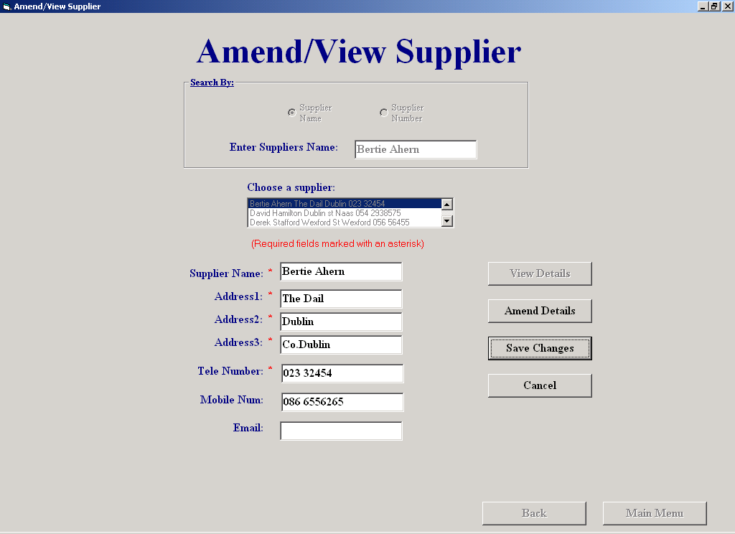

Code:

This screen will allows the user amend or simply view an existing supplier's details
The user enters the supplier's id, name or browses to select a supplier.
When found, the rest of the supplier's details are displayed in view mode. The user can then click
the "Amend" button and amend the details. After clicking "Save Changes", and after confirming to save,
'the changes will be saved. If the user clicks "Cancel", all amendments are cancelled and the previous details
are restored

Author: Sean O'Brien
Date: 20-03-2002

Variables Used -
MyArray : Variant (An array which holds the previous details of the supplier
MyString : String (holds all the previous details)
strSQL : String (holds an SQL statement)
MyString : String (Stores the supplier name)
Answer : Boolean (indicates whether to save amendments)
TheId : Integer (Holds a supplier id)
counter : Integer (Control variable in a loop)
CountUp : Integer (indicates whether the value in a textbox is numeric or not)

Objects used -
TheControl : Data Control (Used to access the supplier table in the database)

Option Explicit

Private Sub cmdAmend_Click()
(Sets the screen to amend mode, saves previous details)
cmdAmend.Tag = TheControl.Recordset("Supplier Name") + "," + _
TheControl.Recordset("Address 1") + "," + TheControl.Recordset("Address 2") + "," + _
TheControl.Recordset("Address 3") + "," + TheControl.Recordset("Phone No") + "," + _
TheControl.Recordset("Mobile No") + "," + TheControl.Recordset("E-mail")
txtSuppName.Enabled = False
optNumber.Enabled = False
optName.Enabled = False
lstSupplier.Enabled = False
cmdSave.Visible = True
Cmdcancel.Visible = True
lblAsterisk.Visible = True
lblAst1.Visible = True
lblAst2.Visible = True
lblAst3.Visible = True
lblAst4.Visible = True
lblAst5.Visible = True
txtSuppNameAm.Text = TheControl.Recordset("Supplier Name")
txtSuppNameAm.Enabled = True
txtAdd1.Enabled = True
txtAdd2.Enabled = True
txtAdd3.Enabled = True
txtTelNum.Enabled = True
txtMobNum.Enabled = True
txtEmail.Enabled = True
cmdBack.Enabled = False
cmdMainMenu.Enabled = False
cmdDisplay.Enabled = False
End Sub

Private Sub DisplayDetails()
(Displays supplier details)
txtSuppNameAm.Text = TheControl.Recordset("Supplier Name")
txtAdd1.Text = TheControl.Recordset("Address 1")
txtAdd2.Text = TheControl.Recordset("Address 2")
txtAdd3.Text = TheControl.Recordset("Address 3")
txtTelNum.Text = TheControl.Recordset("Phone No")
txtMobNum.Text = TheControl.Recordset("Mobile No")
txtEmail.Text = TheControl.Recordset("E-mail")
If optNumber.Value = True Then
txtSuppName.Text = Str(TheControl.Recordset("Supplier_ID"))
Else
txtSuppName.Text = TheControl.Recordset("Supplier Name")
End If
cmdAmend.Enabled = True
End Sub

Private Sub Reset1()
(Resets the screen to view mode)
txtSuppName.Visible = True
lblNamesupp.Visible = True
optNumber.Enabled = True
optName.Enabled = True
lstSupplier.Enabled = True
txtSuppName.Enabled = True
cmdSave.Visible = False
Cmdcancel.Visible = False
cmdBack.Enabled = True
cmdMainMenu.Enabled = True
lblAsterisk.Visible = False
lblAst1.Visible = False
lblAst2.Visible = False
lblAst3.Visible = False
lblAst4.Visible = False
lblAst5.Visible = False
txtAdd1.Enabled = False
txtAdd2.Enabled = False
txtAdd3.Enabled = False
txtSuppNameAm.Enabled = False
txtTelNum.Enabled = False
txtMobNum.Enabled = False
txtEmail.Enabled = False
If optName.Value = True Then
lblNamesupp.Visible = True
lblNumber.Visible = False
Else
lblNamesupp.Visible = False
lblNumber.Visible = True
End If
End Sub
Private Sub cmdBack_Click()
(Unloads this screen and shows the Supplier Maintenance Menu)
frmSupplierMaintenanceMenu.Show
Unload Me
End Sub

Private Sub cmdCancel_Click()
(Cancels any changes to the suppliers details and restores the original details)
Dim MyArray
Dim MyString As String
MyString = cmdAmend.Tag
MyArray = Split(MyString, ",")
txtSuppNameAm.Text = MyArray(0)
txtAdd1.Text = MyArray(1)
txtAdd2.Text = MyArray(2)
txtAdd3.Text = MyArray(3)
txtTelNum.Text = MyArray(4)
txtMobNum.Text = MyArray(5)
txtEmail.Text = MyArray(6)
Call Reset1
End Sub

Private Sub cmdDisplay_Click()
(Finds the first supplier which matches the criteria entered by the user, calls a procedure which displays the details)
Dim strSQL, MyString As String
MyString = txtSuppName.Text
If optName.Value = True Then
strSQL = "Select * From Supplier " & _
"Where Deletion = False " & _
"And [Supplier Name] Like '" & MyString & "'"
txtSuppName.Text = ""
Else
strSQL = "Select * From Supplier " & _
"Where Deletion = False " & _
"And Supplier_ID = " & MyString & ""
End If
TheControl.RecordSource = strSQL
TheControl.Refresh
If optName.Value = True Then
TheControl.Recordset.FindFirst "[Supplier Name] = '" & MyString & "'"
Else
TheControl.Recordset.FindFirst "[Supplier_ID] = " & MyString & ""
End If
If TheControl.Recordset.NoMatch Then
frmNotFound.Visible = True
Else
Call DisplayDetails
End If
End Sub

Private Sub cmdMainMenu_Click()
(Unloads this screen and shows the Main Menu)
frmMainMenu.Show
Unload Me
End Sub

Private Sub cmdSave_Click()
(Saves any amendments to the suppliers details)
Dim Answer As Integer
cmdSave.Tag = TheControl.Recordset("Supplier_ID")
If (Len(txtSuppNameAm.Text) > 0) And (Len(txtAdd1.Text) > 0) And (Len(txtAdd2.Text) > 0) And (Len(txtAdd3.Text) > 0) And (Len(txtTelNum.Text) > 0) Then
Answer = MsgBox("Are you sure?", vbYesNo + vbQuestion, "Warning")
If Answer = vbYes Then
TheControl.Recordset.Edit
TheControl.Recordset("Supplier Name") = txtSuppNameAm.Text
TheControl.Recordset("Address 1") = txtAdd1.Text
TheControl.Recordset("Address 2") = txtAdd2.Text
TheControl.Recordset("Address 3") = txtAdd3.Text
TheControl.Recordset("Phone No") = txtTelNum.Text
TheControl.Recordset("Mobile No") = txtMobNum.Text
TheControl.Recordset("E-mail") = txtEmail.Text
TheControl.Recordset.Update
Call MsgBox("The changes have been saved", , "Save Successful")
If optName.Value = True Then
txtSuppName.Text = TheControl.Recordset("Supplier Name")
Else
txtSuppName.Text = TheControl.Recordset("Supplier_ID")
End If
TheControl.RecordSource = "Select*from Supplier where [Deletion] = False"
TheControl.Refresh
lstSupplier.Clear
While Not TheControl.Recordset.EOF
lstSupplier.AddItem (TheControl.Recordset("Supplier Name") & " " & TheControl.Recordset("Address 1") & " " & TheControl.Recordset("Address 2") & " " & TheControl.Recordset("Phone No"))
lstSupplier.ItemData(lstSupplier.NewIndex) = TheControl.Recordset("Supplier_ID")
TheControl.Recordset.MoveNext
Wend
Call Reset1
End If
Else
Call MsgBox("One or more required fields left empty, details will not be stored", , "Warning")
End If
TheControl.Recordset.FindFirst "Supplier_ID = " & cmdSave.Tag & ""
End Sub

Private Sub Form_Activate()
(Displays every supplier and some of their details in a listbox)
txtSuppName.SetFocus
While Not TheControl.Recordset.EOF
lstSupplier.AddItem (TheControl.Recordset("Supplier Name") & " " & TheControl.Recordset("Address 1") & " " & TheControl.Recordset("Address 2") & " " & TheControl.Recordset("Phone No"))
lstSupplier.ItemData(lstSupplier.NewIndex) = TheControl.Recordset("Supplier_ID")
TheControl.Recordset.MoveNext
Wend
TheControl.Refresh
End Sub

Private Sub Form_Load()
(Sets the data control to access the details of the supplier table in the database)
TheControl.DatabaseName = strThePath
TheControl.RecordSource = "Select*from Supplier where [Deletion] = False"
TheControl.Refresh
End Sub

Private Sub lstSupplier_Click()
(Displays the details of whatever supplier that was chosen by the user from the listbox)
Dim TheId As Integer
TheId = lstSupplier.ItemData(lstSupplier.ListIndex)
TheControl.RecordSource = "Select*from Supplier where [Deletion] = False;"
TheControl.Refresh
TheControl.Recordset.FindFirst "Supplier_ID = " & TheId & ""
txtSuppNameAm.Visible = True
lblName.Visible = True
cmdDisplay.Enabled = False
txtSuppName.Text = ""
Call DisplayDetails
End Sub

Private Sub OptName_Click()
(Shows the label "lblNamesupp")
If optName.Value = True Then
lblNumber.Visible = False
lblNamesupp.Visible = True
txtSuppName.SetFocus
End If
End Sub

Private Sub optNumber_Click()
(Shows the label "lblNumber")
If optNumber.Value = True Then
lblNumber.Visible = True
lblNamesupp.Visible = False
txtSuppName.SetFocus
End If
End Sub

Private Sub txtAdd1_GotFocus()
(Highlights whatever text is in this textbox)
txtAdd1.SelStart = 0
txtAdd1.SelLength = Len(txtAdd1)
End Sub

Private Sub txtAdd2_GotFocus()
(Highlights whatever text is in this textbox)
txtAdd2.SelStart = 0
txtAdd2.SelLength = Len(txtAdd2)
End Sub

Private Sub txtAdd3_GotFocus()
(Highlights whatever text is in this textbox)
txtAdd3.SelStart = 0
txtAdd3.SelLength = Len(txtAdd3)
End Sub

Private Sub txtEmail_GotFocus()
(Highlights whatever text is in this textbox)
txtEmail.SelStart = 0
txtEmail.SelLength = Len(txtEmail)
End Sub

Private Sub txtMobNum_GotFocus()
(Highlights whatever text is in this textbox)
txtMobNum.SelStart = 0
txtMobNum.SelLength = Len(txtMobNum)
End Sub

Private Sub txtMobNum_Validate(Cancel As Boolean)
(Ensures the user enters valid data into this textbox)
Dim counter, CountUp As Integer
CountUp = 0
If (Len(txtMobNum.Text) > 0) Then
For counter = 1 To Len(txtMobNum.Text)
If IsNumeric(Mid(txtMobNum, counter, 1)) Then
CountUp = CountUp + 1
End If
Next
If (CountUp = (Len(txtMobNum.Text) - 1)) Or (CountUp = Len(txtMobNum.Text)) Then
Cancel = False
Else
Cancel = True
Call MsgBox("This is not a valid mobile number", vbOKOnly, "Warning")
txtMobNum.SetFocus
End If
Cancel = False
End If
End Sub

Private Sub txtSuppName_GotFocus()
(Empties all the supplier details out of the textboxes)
txtSuppNameAm.Text = ""
txtSuppName.Text = ""
txtAdd1.Text = ""
txtAdd2.Text = ""
txtAdd3.Text = ""
txtEmail.Text = ""
txtMobNum.Text = ""
txtTelNum.Text = ""
cmdAmend.Enabled = False
cmdDisplay.Enabled = True
End Sub

Private Sub txtSuppName_Validate(Cancel As Boolean)
(Makes sure that valid data is entered into this textbox)
Dim counter, CountUp As Integer
CountUp = 0
If Len(txtSuppName.Text) = 0 Then
Cancel = True
If optName.Value = True Then
Call MsgBox("Please enter supplier name", vbOKOnly, "Warning")
Else
Call MsgBox("Please enter supplier number", vbOKOnly, "Warning")
End If
txtSuppName.SetFocus
Else
If optNumber = True Then
For counter = 1 To Len(txtSuppName.Text)
If IsNumeric(Mid(txtSuppName, counter, 1)) Then
CountUp = CountUp + 1
End If
Next
If Not (CountUp = Len(txtSuppName.Text)) Then
Cancel = True
Call MsgBox("Supplier ID must be numeric", vbOKOnly, "Warning")
txtSuppName.Text = ""
Else
Cancel = False
End If
Else
Cancel = False
End If
End If
End Sub

Private Sub txtSuppNameAm_GotFocus()
(Highlights whatever text is in this textbox)
txtSuppNameAm.SelStart = 0
txtSuppNameAm.SelLength = Len(txtSuppNameAm)
End Sub

Private Sub txtTelNum_GotFocus()
(Highlights whatever text is in this textbox)
txtTelNum.SelStart = 0
txtTelNum.SelLength = Len(txtTelNum)
End Sub
Private Sub txtTelNum_Validate(Cancel As Boolean)
(Ensures the user enters valid data into this textbox)
Dim counter, CountUp As Integer
CountUp = 0
If Len(txtTelNum.Text) = 0 Then
Cancel = True
MsgBox "Please enter Telephone Number", vbOKOnly, "Warning"
txtTelNum.SetFocus
Else
For counter = 1 To Len(txtTelNum.Text)
If IsNumeric(Mid(txtTelNum, counter, 1)) Then
CountUp = CountUp + 1
End If
Next
If (CountUp = (Len(txtTelNum.Text) - 1)) Or (CountUp = Len(txtTelNum.Text)) Then
Cancel = False
Else
Cancel = True
Call MsgBox("This is not a valid phone number", vbOKOnly, "Warning")
txtTelNum.SetFocus
End If
Cancel = False
End If
End Sub

Delete a Staff Member

Screen Shot:

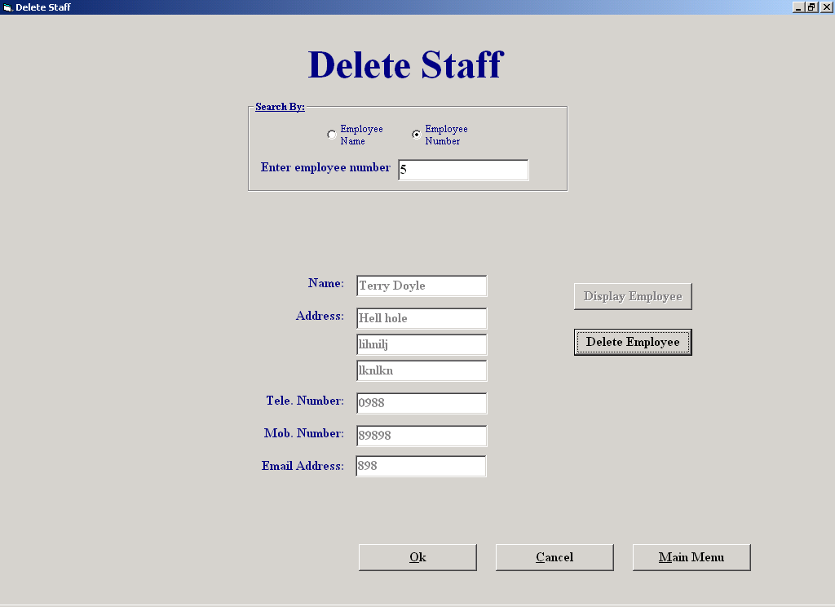

Code:

This screen allows the user to delete an existing staff member's details from the database
The user enters the staff member's ID or name, the system then searches the Staff table for that number or name. When found, the rest of the staff member's details are displayed. The user then has the option of deleting the record from the database by clicking the "Delete Employee" button, repeat the process for another staff member or exit the screen without saving any deletions by clicking the "Cancel" button.

Author: Sean O'Brien
Date: 20-03-2002

Variables Used -
Answer : Integer (indicates whether or not to delete the employee)
MyArray : Variant (An array which holds the ID's of the staff that was deleted)
MyString : String (holds all the id's of the staff that was deleted)
strSQL : String (holds an SQL statement)
Answer : Boolean (indicates whether to save deletions)
TheId : Integer (Holds an employee id)
index : Integer (a control variable in a loop)
MyString : String (holds all the name of the employee)
counter : Integer (Control variable in a loop)
CountUp : Integer (indicates whether the value in a textbox is numeric or not

Objects Used -
datCount : Data Control (Used to access the employee table in the database)
datStaff : Data Control (Used to access the employee table in the database)

Option Explicit

Private Sub cmdBack_Click()
(Unloads this form and shows the Staff Maintenance Menu)
frmStaffMenu.Show
Unload Me
End Sub

Public Sub DisplayDetails()
(Displays the employees details)
cmdDelEmp.Enabled = True
txtEmpName.Text = datStaff.Recordset("Employee Name")
txtAddress1.Text = datStaff.Recordset("Address 1")
txtAddress2.Text = datStaff.Recordset("Address 2")
txtAddress3.Text = datStaff.Recordset("Address 3")
txtTelNum.Text = datStaff.Recordset("Phone No")
txtMobNum.Text = datStaff.Recordset("Mobile No")
txtEmail.Text = datStaff.Recordset("E-mail")
cmdViewEmp.Enabled = False
End Sub

Private Sub Reset1()
(Resets the screen, empties the textboxes)
txtEmpName.Text = ""
txtAddress1.Text = ""
txtAddress2.Text = ""
txtAddress3.Text = ""
txtTelNum.Text = ""
txtMobNum.Text = ""
txtEnteredName.Text = ""
txtEmail.Text = ""
lstStaff.Visible = False
lblMoreThan1.Visible = False
End Sub

Private Sub cmdDelEmp_Click()
(Deletes the employee from the database (marks for deletion))
Dim Answer As Integer
Answer = MsgBox("Are you sure?", vbYesNo + vbQuestion, "Warning")
If Answer = vbYes Then
datStaff.Recordset.Edit
datStaff.Recordset("Deletion") = True
cmdDelEmp.Tag = cmdDelEmp.Tag + Str(datStaff.Recordset("Employee_ID")) + ","
frmDelStaff.Tag = Str(Val(frmDelStaff.Tag) + 1)
datStaff.Recordset.Update
Call MsgBox("The employee has been deleted", vbExclamation, "Deletion Sucessful")
txtEnteredName.SetFocus
End If
End Sub

Private Sub cmdMainMenu_Click()
(Unloads this form and shows the Main Menu)
frmMainMenu.Visible = True
Unload Me
End Sub

Private Sub cmdNoSave_Click()
(Cancels all deletions made by the user since the screen was accessed)
Dim TheArray
Dim MyString As String
Dim TheId, index, Answer As Integer
If Val(frmDelStaff.Tag) > 0 Then
Answer = MsgBox("Are you sure you want to cancel all deletions that you made?", vbYesNo + vbQuestion, "Warning")
If Answer = vbYes Then
MyString = cmdDelEmp.Tag
TheArray = Split(MyString, ",")
datStaff.RecordSource = "Employee"
datStaff.Refresh
index = 0
While index < Val(frmDelStaff.Tag)
TheId = TheArray(index)
datStaff.Recordset.FindFirst "Employee_ID = " & TheId & ""
datStaff.Recordset.Edit
datStaff.Recordset("Deletion") = False
datStaff.Recordset.Update
index = index + 1
Wend
Call MsgBox("The deletions that you made were not saved", vbOKOnly, "Deletions Cancelled")
Else
Call MsgBox("The changes that you made will be saved", vbOKOnly, "Deletions Saved")
End If
End If
frmStaffMenu.Show
Unload Me
End Sub

Private Sub cmdViewEmp_Click()
(Searches for the employee and when found, calls a procedure which displays the employees details)
Dim MyString, strSQL As String
MyString = txtEnteredName.Text
If optName.Value = True Then
strSQL = "Select * From Employee " & _
"Where Deletion = False " & _
"And [Employee Name] = '" & MyString & "'"
Else
strSQL = "Select * From Employee " & _
"Where Deletion = False " & _
"And Employee_ID = " & MyString & ""
End If
datStaff.DatabaseName = strThePath
datStaff.RecordSource = strSQL
datStaff.Refresh
datCount.RecordSource = "SELECT Count(*) AS TheCount From Employee Where Deletion = False And [Employee Name] = '" & MyString & "'"
datCount.Refresh
If datCount.Recordset.Fields("TheCount") > 1 Then
While Not datStaff.Recordset.EOF
lstStaff.AddItem (datStaff.Recordset("Employee Name") & " " & datStaff.Recordset("Address 1"))
lstStaff.ItemData(lstStaff.NewIndex) = datStaff.Recordset("Employee_ID")
datStaff.Recordset.MoveNext
Wend
lblMoreThan1.Visible = True
lstStaff.Visible = True
Else
If optName.Value = True Then
datStaff.Recordset.FindFirst "[Employee Name] = '" & MyString & "'"
Else
datStaff.Recordset.FindFirst "Employee_ID = " & MyString & ""
End If
If datStaff.Recordset.NoMatch Then
txtEnteredName.SetFocus
txtEnteredName.Text = ""
If optName.Value = True Then
Call MsgBox("Employee not found, please make sure you have the name spelled correctly and that the employee exists", vbOKOnly, "Search Failed")
Else
Call MsgBox("Employee not found, please make sure that the employee exists", vbOKOnly, "Search Failed")
End If
Else
Call DisplayDetails
End If
End If
datStaff.Refresh
End Sub

Private Sub Form_Activate()
(Puts focus in a textbox called "txtEnteredName")
txtEnteredName.SetFocus
End Sub

Private Sub Form_Load()
(Sets the data control to access the details of the employee table in the database)
datCount.DatabaseName = strThePath
datCount.RecordSource = "Employee"
datCount.Refresh
cmdDelEmp.Tag = ""
frmDelStaff.Tag = "0"
End Sub

Private Sub lstStaff_Click()
(Finds the employee and then calls a procedure to display its details)
Dim TheId As Integer
TheId = lstStaff.ItemData(lstStaff.ListIndex)
datStaff.Recordset.FindFirst "Employee_ID = " & TheId & ""
If optNumber.Value = True Then
txtEnteredName.Text = Str(TheId)
End If
Call DisplayDetails
End Sub

Private Sub OptName_Click()
If optName.Value = True Then
lblNumber.Visible = False
lblName.Visible = True
txtEnteredName.SetFocus
End If
End Sub

Private Sub optNumber_Click()
If optNumber.Value = True Then
lblNumber.Visible = True
lblName.Visible = False
txtEnteredName.SetFocus
End If
End Sub

Private Sub txtEnteredName_GotFocus()
cmdDelEmp.Enabled = False
cmdViewEmp.Enabled = True
Reset1
End Sub

Private Sub txtEnteredName_Validate(Cancel As Boolean)
(Ensures valid data is entered in this textbox)
Dim CountUp, counter As Integer
CountUp = 0
If Len(txtEnteredName.Text) = 0 Then
If optName.Value = True Then
Cancel = True
If MsgBox("Please enter employee name", vbOKOnly, "Warning") = vbOK Then
txtEnteredName.SetFocus
End If
Else
Cancel = True
If MsgBox("Please enter employee number", vbOKOnly, "Warning") = vbOK Then
txtEnteredName.SetFocus
End If
End If
Else
If optName.Value = True Then
If IsNumeric(txtEnteredName.Text) Then
Cancel = True
txtEnteredName.SetFocus
txtEnteredName.Text = ""
Call MsgBox("Please enter a valid name", vbOKOnly, "Warning")
Else
Cancel = False
End If
Else
For counter = 1 To Len(txtEnteredName.Text)
If IsNumeric(Mid(txtEnteredName, counter, 1)) Then
CountUp = CountUp + 1
End If
Next
If (CountUp = Len(txtEnteredName.Text)) Then
Cancel = False
Else
Cancel = True
Call MsgBox("Employee id must be numeric", vbOKOnly, "Warning")
txtEnteredName.SetFocus
txtEnteredName.Text = ""
End If
End If
End Sub

Customer Report

Screen Shot:

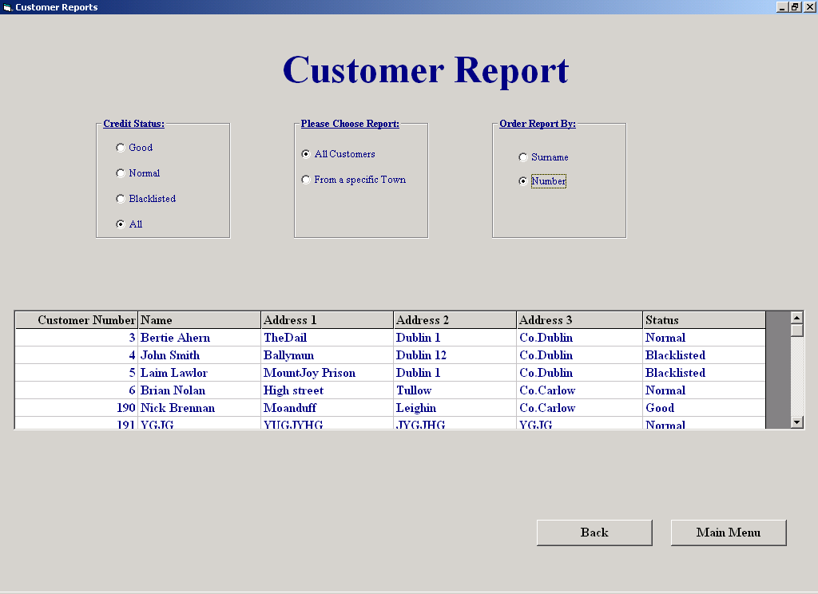

Code:

This screen allows the user to produce reports on customer details.
'The user can select a Credit Status and then get a list of all customers matching it by clicking "All customers", or get a list of all customers from a particular town with the credit status by clicking "From a Specific town". The report can then be sorted by Customer Surname, by clicking "SurName" or, it can be sorted by Customer Number by clicking "Number".

Author: Sean O'Brien
Date: 20-03-2002

Variables Used -
strSQL : String (Holds SQL statements"
MyString : String (Holds credit status)
TheTown : String (holds the town name)
TheName : String (holds customer's full name)
FName : String (holds customer's first name)
LName : String (holds customer's last name)
dbs : Database (opens the database to create a temporary table called “Temp")
Rec : Recordset (Used to access a temporary table called "Temp", in the database)
MyArray : Variant (An array which holds the name the Surname and first name of the customer)
counter : Integer (indicates the amount of spaces in the name of the customer)

Objects Used -
datReport : Data Control (used to access the Customer and Temp tables in the database)

Option Explicit

Private Sub cmdBack_Click()
(Unloads this screen and shows the Reports Menu)
frmReportsMenu.Show
Unload Me
End Sub

Public Sub Sort()
(Displays all customers matching the criteria entered by the user)
Dim strSQL, MyString, TheTown As String
If optGood.Value Then
MyString = "Good"
If optCustNum.Value Then
If optTown.Value Then
strSQL = "Select CustNum as [Customer Number], FName as Name, Add1 as [Address 1]," & _
"Add2 as [Address 2], Add3 as [Address 3], Status From Temp " & _
"Where Status = '" & MyString & "'" & "And Add1 = '" & txtTown.Text & "'" & _
"Order By CustNum"
Else
strSQL = "Select CustNum as [Customer Number], FName as Name, Add1 as [Address 1], Add2 as [Address 2]," & _
"Add3 as [Address 3], Status From Temp " & _
"Where Status = '" & MyString & "'" & " Order By CustNum"
End If
Else
If optTown.Value Then
strSQL = "Select CustNum as [Customer Number], FName as Name, Add1 as [Address 1]," & _
"Add2 as [Address 2], Add3 as [Address 3], Status From Temp " & _
"Where Status = '" & MyString & "'" & "And Add1 = '" & txtTown.Text & "'" & _
"Order By LName"
Else
strSQL = "Select CustNum as [Customer Number], FName as Name, Add1 as [Address 1], Add2 as [Address 2]," & _
"Add3 as [Address 3], Status From Temp " & _
"Where Status = '" & MyString & "'" & " Order By LName"
End If
End If
Else
If optNormal.Value Then
MyString = "Normal"
If optCustNum.Value Then
If optTown.Value Then
strSQL = "Select CustNum as [Customer Number], FName as Name, Add1 as [Address 1]," & _
"Add2 as [Address 2], Add3 as [Address 3], Status From Temp " & _
"Where Status = '" & MyString & "'" & "And Add1 = '" & txtTown.Text & "'" & _
"Order By CustNum"
Else
strSQL = "Select CustNum as [Customer Number], FName as Name, Add1 as [Address 1], Add2 as [Address 2]," & _
"Add3 as [Address 3], Status From Temp " & _
"Where Status = '" & MyString & "'" & " Order By CustNum"
End If
Else
If optTown.Value Then
strSQL = "Select CustNum as [Customer Number], FName as Name, Add1 as [Address 1]," & _
"Add2 as [Address 2], Add3 as [Address 3], Status From Temp " & _
"Where Status = '" & MyString & "'" & "And Add1 = '" & txtTown.Text & "'" & _
"Order By LName"
Else
strSQL = "Select CustNum as [Customer Number], FName as Name, Add1 as [Address 1], Add2 as [Address 2]," & _
"Add3 as [Address 3], Status From Temp " & _
"Where Status = '" & MyString & "'" & " Order By LName"
End If
End If
Else
If optBlack.Value = True Then
MyString = "BlackListed"
If optCustNum.Value Then
If optTown.Value Then
strSQL = "Select CustNum as [Customer Number], FName as Name, Add1 as [Address 1]," & _
"Add2 as [Address 2], Add3 as [Address 3], Status From Temp " & _
"Where Status = '" & MyString & "'" & "And Add1 = '" & txtTown.Text & "'" & _
"Order By CustNum"
Else
strSQL = "Select CustNum as [Customer Number], FName as Name, Add1 as [Address 1], Add2 as [Address 2]," & _
"Add3 as [Address 3], Status From Temp " & _
"Where Status = '" & MyString & "'" & " Order By CustNum"
End If
Else
If optTown.Value = True Then
strSQL = "Select CustNum as [Customer Number], FName as Name, Add1 as [Address 1]," & _
"Add2 as [Address 2], Add3 as [Address 3], Status From Temp " & _
"Where Status = '" & MyString & "'" & "And Add1 = '" & txtTown.Text & "'" & _
"Order By LName"
Else
strSQL = "Select CustNum as [Customer Number], FName as Name, Add1 as [Address 1], Add2 as [Address 2]," & _
"Add3 as [Address 3], Status From Temp " & _
"Where Status = '" & MyString & "'" & " Order By LName"
End If
End If
Else
If optAll.Value = True Then
If optTown.Value Then
If optCustNum.Value = True Then
strSQL = "Select CustNum as [Customer Number], FName as Name, Add1 as [Address 1]," & _
"Add2 as [Address 2], Add3 as [Address 3], Status From Temp Where Add1 = '" & _
txtTown.Text & "'" & "Order By CustNum"
Else
strSQL = "Select CustNum as [Customer Number], FName as Name, Add1 as [Address 1]," & _
"Add2 as [Address 2], Add3 as [Address 3], Status From Temp Where Add1 = '" & _
txtTown.Text & "'" & "Order By LName"
End If
Else
If optCustNum.Value = True Then
strSQL = "Select CustNum as [Customer Number], FName as Name, Add1 as [Address 1]," & _
"Add2 as [Address 2], Add3 as [Address 3], Status From Temp Order By CustNum"
Else
strSQL = "Select CustNum as [Customer Number], FName as Name, Add1 as [Address 1]," & _
"Add2 as [Address 2], Add3 as [Address 3], Status From Temp Order By LName"
End If
End If
End If
End If
End If
End If
datReport.DatabaseName = strThePath
datReport.RecordSource = strSQL
datReport.Refresh
If datReport.Recordset.RecordCount = 0 Then
Call MsgBox("Search is complete, there was no results to display", vbOKOnly, "No Matches")
Else
gridReport.Visible = True
End If
End Sub

Private Sub cmdViewRep_Click()
Sort
End Sub

Private Sub cmdMainMenu_Click()
(Unloads this screen and shows the Main Menu)
frmMainMenu.Show
Unload Me
End Sub

Private Sub Form_Activate()
OrderByNames
End Sub

Private Sub Form_Load()
(Sets the data control, "datReport" to access the details of the Customer table in the database)
datReport.DatabaseName = strThePath
datReport.RecordSource = "Select * from Customer where [Deletion] = False"
datReport.Refresh
gridReport.Clear
End Sub

Private Sub Form_Unload(Cancel As Integer)
(Deletes the temporary table that was created)
datReport.RecordSource = "Customer"
datReport.Refresh
Dim dbs As Database
Set dbs = OpenDatabase(strThePath)
dbs.Execute ("Drop Table Temp")
End Sub

Private Sub optAll_Click()
Reset
optTown.Value = False
optAllCust.Value = False
End Sub

Private Sub optAllCust_Click()
Reset
optTown.Value = False
optSurName.Enabled = True
optCustNum.Enabled = True
End Sub

Private Sub optBlack_Click()
Reset
optTown.Value = False
optAllCust.Value = False
End Sub

Private Sub optCustNum_Click()
Sort
End Sub

Private Sub optGood_Click()
Reset
optTown.Value = False
optAllCust.Value = False
End Sub

Private Sub optNormal_Click()
Reset
optTown.Value = False
optAllCust.Value = False
End Sub

Private Sub optSurName_Click()
Sort
End Sub

Public Sub OrderByNames()
(Creates a temporary table called "Temp",for the purpose of ordering the report by SurName
(The name of the Customer is all in the one field))
Dim strSQL, TheName, FName, LName As String
Dim dbs As Database
Dim Rec As Recordset
Dim MyArray
Dim counter As Integer
counter = 0
Set dbs = OpenDatabase(strThePath)
dbs.Execute ("CREATE TABLE Temp") _
& ("( CustNum NUMBER, FName TEXT, LName TEXT,") _
& ("Add1 TEXT, Add2 TEXT, Add3 TEXT, Status TEXT)") 'creates a temporary table called Temp
Set Rec = dbs.OpenRecordset("Temp", dbOpenDynaset)
strSQL = "Select Cust_ID, Name,[Address 1], [Address 2], [Address 3], Status From Customer " & _
"Where Deletion = False "
datReport.RecordSource = strSQL
datReport.Refresh
While Not datReport.Recordset.EOF
TheName = datReport.Recordset("Name")
MyArray = Split(TheName, " ") 'breaks up the Name of the customer
FName = MyArray(0) 'first name goes into "FName"
If Not (Len(FName) = Len(TheName)) Then 'this is true if there is only one word in the name
LName = MyArray(1)
counter = Len(Replace(TheName, " ", " " & "*")) - Len(TheName) 'finds the number of spaces in the Name
If counter > 1 Then
LName = LName + " " + MyArray(2)
End If
FName = FName & " " & LName
Else
LName = ""
End If
Rec.AddNew
Rec("CustNum") = datReport.Recordset("Cust_ID")
Rec("FName") = FName
Rec("LName") = LName
Rec("Add1") = datReport.Recordset("Address 1")
Rec("Add2") = datReport.Recordset("Address 2")
Rec("Add3") = datReport.Recordset("Address 3")
Rec("Status") = datReport.Recordset("Status")
Rec.Update
datReport.Recordset.MoveNext
Wend
End Sub

Private Sub optTown_Click()
(Allows the user to click the option buttons "optCustNum" and "optSurName")
optCustNum.Enabled = True
optSurName.Enabled = True
optSurName.Value = False
optCustNum.Value = False
gridReport.Visible = False
lblTown.Visible = True
txtTown.Visible = True
txtTown.SetFocus
End Sub

Private Sub txtTown_GotFocus()
txtTown.Text = ""
optCustNum.Value = False
optSurName.Value = False
gridReport.Visible = False
End Sub

Private Sub txtTown_Validate(Cancel As Boolean)
(Ensures the user enters a valid town name)
If Len(txtTown.Text) > 0 Then
If Not IsNumeric(txtTown.Text) Then
Cancel = False
Else
Cancel = True
Call MsgBox("Please enter a valid town name", vbOKOnly, "Warning")
txtTown.SetFocus
End If
Else
Cancel = True
Call MsgBox("Please enter a town", vbOKOnly, "Warning")
txtTown.SetFocus
End If
End Sub

Public Sub Reset()
(Resets the screen)
optSurName.Value = False
optCustNum.Value = False
optSurName.Enabled = False
optCustNum.Enabled = False
gridReport.Visible = False
lblTown.Visible = False
txtTown.Visible = False
End Sub

